Pop up Twist Card:

Cut a 12x12 CS into the following pieces:
A: 12 x 4 (Base)
B: 10 x 3.5 (Display Arm)
C: 8 x 3.5 (Mechanism)

Piece A: Score and fold in half for a top fold card base.

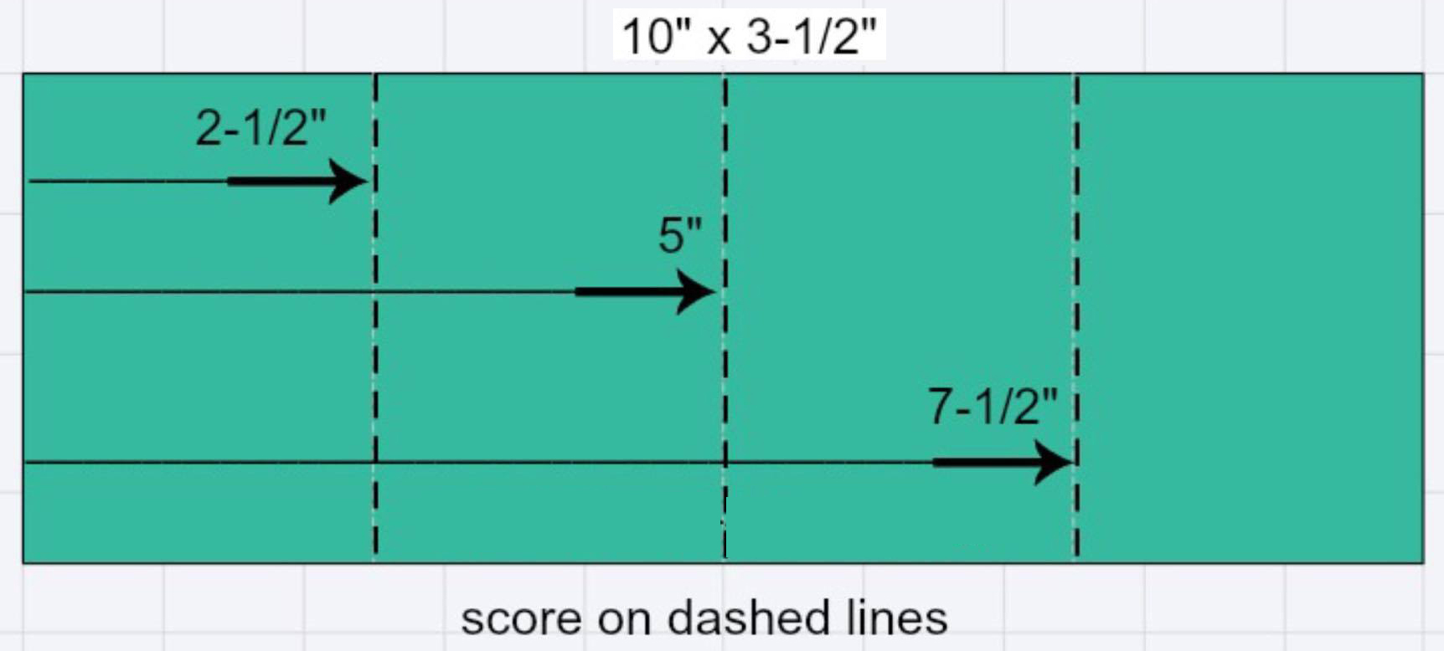
Piece B: Score and fold per photo. This folds into a 'W' and the center is pointed up like a tent.
Piece C: Score per photo, then fold each angel and center.
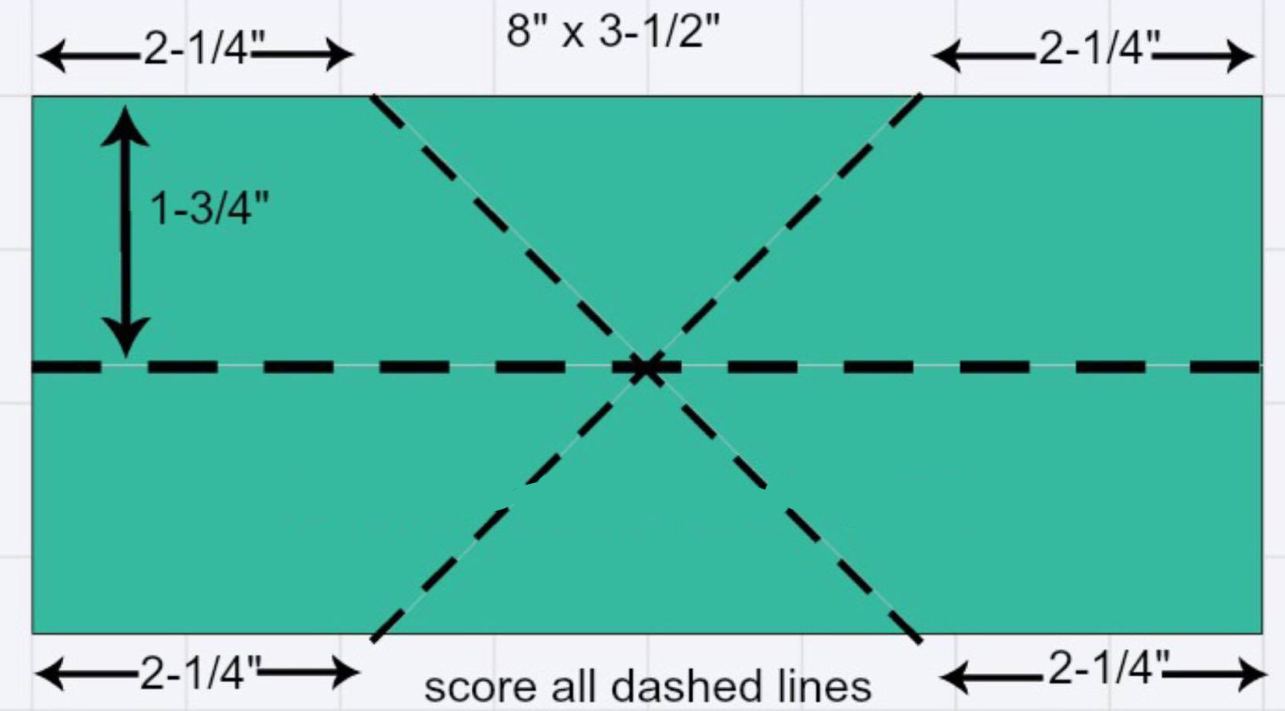
It should look like this when you're done.
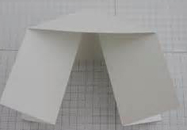
You will now attach piece C to your base. Line the tip of the triangle on C in the middle of your base (A) directly below the fold. Put glue on the triangle that is face up and close the base to attach C to the base (A). Flip the whole unit over, open base, apply glue to triangle and close base again to attach.

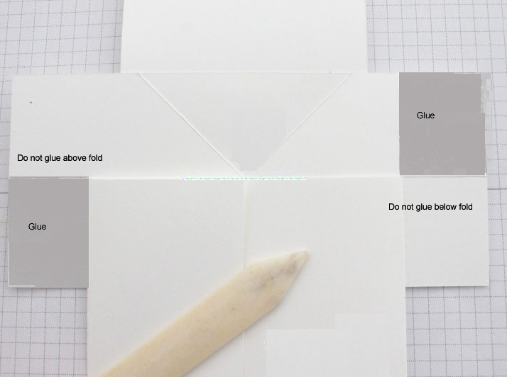
Next you want to line up the center of B with the center of C. DO NOT GLUE. Fold the two sides of B towards the center exposing some of C.

Put glue in the places indicated on the photo.

Unfold the two ends of B to
attach them to C (over the glued areas)

Now carefully fold the card closed.

Hints: The “W” or piece B needs to pop up in the center while the “legs” on piece C need to push in towards each other.
Crisp folds really help this card work more smoothly.

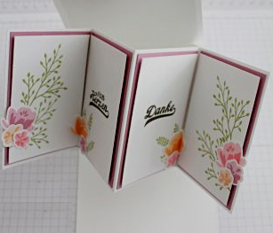
Now Decorate as you wish!

The arm panels are 3.5 x 2.5 and I found a 4 x 4 works for covering the top and bottom of the inside. The front cover is 4x6.

